MODULE 2
Data Warehouse Design – Analytical operations of OLAP
Aim:
To perform analytical operations of Online Analytical Processing such as Rollup, Drill down, Slicing, Dicing, Pivot in Cube Multi-Dimensional data model.
Objective:
- To organize the Bird Migration dataset into multiple dimensions for analytical processing.
- To create a multidimensional data view (cube) using migration-related data.
- To perform OLAP operations such as Roll-up, Drill-down, Slice, Dice and Pivot.
- To analyze the impact of environmental conditions on bird migration.
Procedure:
In the multidimensional model, data are organized into multiple dimensions, and each dimension contains multiple levels of abstraction defined by concept hierarchies. This organization provides users with the flexibility to view data from different perspectives.
Step 1: Create Fact and Dimension Table and upload the values for all the attributes specified in each table
Step 2: Create Multidimensional data view as cube in PostgreSQL
Step 3: Perform OLAP operations for analytical processing of cubical data.
OLAP operations:
OLAP provides a user-friendly environment for interactive data analysis. A number of OLAP data cube operations exist to materialize different views of data, allowing interactive querying and analysis of the data.The operations are:
- Roll up
- Roll down
- Slicing
- Dicing

1.Defining the Business Process Model:
This Business process focuses on tracking, recording, and analysing bird migration movements from origin locations to destination locations across different locations. Each record in the dataset represents a migration observation event for a particular bird species.
The process begins with the collection of migration data, where information such as bird species, origin location, destination location, migration success, migration interrupted and predator involvement is recorded. This data is typically gathered through field observations, tracking systems, or ecological studies.
The outcome of this business process is to support ecological research, conservation planning, and migration pattern analysis by enabling structured analysis through OLAP operations such as roll-up, drill-down, slice, and dice.
2.Granularity of the Dataset:
Granularity refers to the level of detail represented by each record in a dataset. In the bird migration dataset, the granularity is defined at a detailed migration-event level.
Each row in the dataset represents one migration observation of a specific bird species, captured for a particular origin location, destination location, migration success or not, and is there any predator involvement.
This means the data is not aggregated at higher levels such as continent or multi-year summaries. Instead, it records migration information at the most specific level available, allowing flexible analysis later.
One record = One bird species migrating from one origin location to one destination location and how it is traced by tag and is there any obstacles by the predator and finally concluding the migration success or not with its flight distance and the speed by which the particular species had travelled.

3.Identifying the Fact and Dimension Tables:
Fact_Bird_Migration is a fact table having attributes i.e. (Bird_ID,Species_ID,Location_ID,Time_ID,Environment_ID, Tag_ID, Migration_Status_ID, Flight_Distance_km, Flight_Duration_hours, Average_Speed_kmph, Max_Altitude_m, Min_Altitude_m, Rest_Stops, Predator_Sightings, Observation_Counts) which references the dimension tables.
Bird dimension table contains the attributes: Bird_ID, Habitat, Migrated_in_Flock, Flock_Size, Food_Supply_Level and Nesting_Success.
Species dimension table contains the attributes: Species_ID, Species_Name, Migration_Reason and Migration_Success.
Location dimension table contains the attributes: Location_ID, Region, Origin, End_Longitude Start_Latitude, Start_Longitude, and Recovery_Location_Known
Time dimension table contains the attributes: Time_ID, Migration_Start_Month, Migration_End_Month and Recovery_Time_days. End_Latitude,
Environment dimension table contains the attributes : Environment_ID,Weather_Condition,Temperature_C,Wind_Speed_kmph, Humidity_Percent, Pressure_hPa and Visibility_km.
Tag dimension table contains the attributes: Tag_ID, Tag_Type, Tag_Weight_g, Tag_Battery_Level, Signal_Strength_dB, Tracking_Quality and Tagged_By.
Migration_Status dimension table contains the attributes: Migration_Status_ID, Migration_Interrupted, Interrupted_Reason and Observation_Quality.

4.Defining the Hierarchy involved in the dataset:
This hierarchy indicates that each bird species can have multiple individual birds, and migration observations are recorded at the level of individual birds.
At the higher level (Bird Species), migration patterns can be analyzed collectively for a species, such as common routes, seasonal behavior, and migration frequency.
At the lower level (Individual Bird), detailed analysis can be performed to study the movement behavior of a specific bird within that species.

5.OLAP OPERATIONS:
Roll up:
The roll-up operation (also called drill-up or aggregation operation) performs aggregation on a data cube, either by climbing up a concept hierarchy for a dimension or by climbing down a concept hierarchy, i.e. dimension reduction.

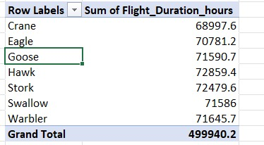
Fig no 2.1 Roll up operation for finding the sum of flight duration(in hours) of species

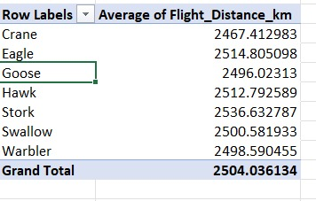
Fig no 2.2 Roll up operation for finding the average flight distance of species

Drill down:
The drill down operation (also called roll down) is the reverse of roll up. It navigates from less detailed data to more detailed data. It can be realized by either stepping down a concept hierarchy for a dimension or introducing additional dimensions. Performing roll down operation on the same cube mentioned above:
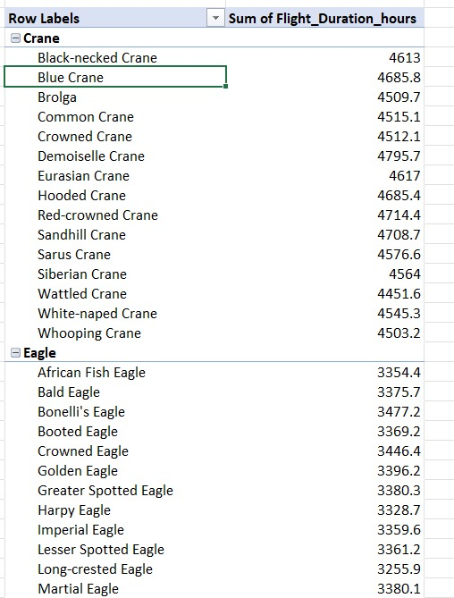
Fig no 2.3 Drill down operation to calculate the flight duration of individual bird

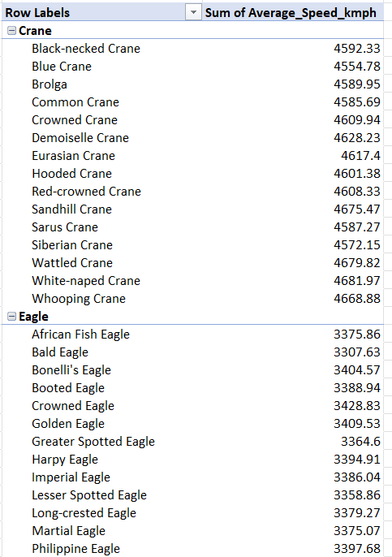
Fig no 2.4 Drill down operation to calculate the average speed of individual bird

Slicing:
Slicing is an OLAP operation used to extract a specific subset of data by fixing a single dimension to a particular value. It reduces a multi-dimensional data cube into a smaller view, making analysis more focused and easier. Slicing helps in studying specific patterns.

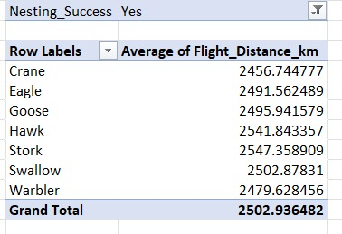
Fig no 2.5 Slicing Operation for Nesting Success is True
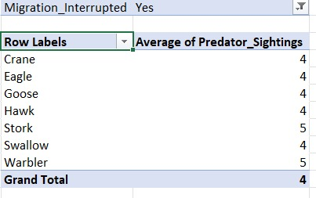
Fig no 2.6 Slicing Operation for Migration Interrupted is True

Dicing:
Dicing is an OLAP operation used to extract a smaller sub-cube from a data cube by applying multiple conditions on one or more dimensions at the same time. Unlike slicing, which fixes a single dimension to one value, dicing selects a range or set of values across dimensions.
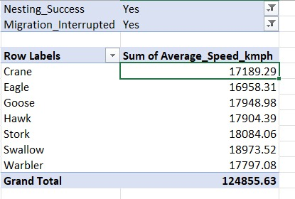
Fig no 2.7 Dicing Operation for Nesting Succes and Migration Interrupted is True

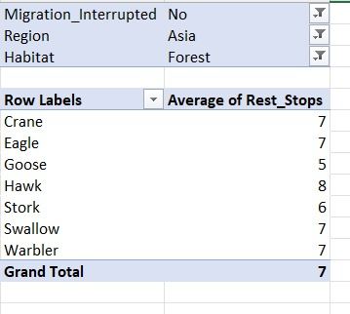
Fig no 2.8 Dicing Operation for no Interruption in Migration and Region is Asia and Habitat is Forest

Pivot:
Pivot otherwise known as Rotate changes the dimensional orientation of the cube, i.e. rotates the data axes to view the data from different perspectives. Pivot groups data with different dimensions.

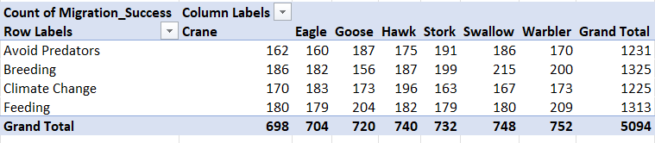
Fig no 2.9 Pivoting the Species and Migration Reason and finding the Migration Success is True
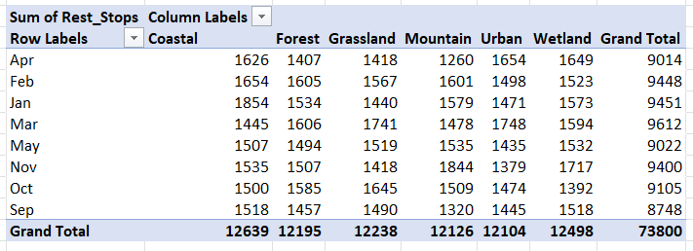
Fig no 2.10 Pivoting the Migration Start Month and the Habitat and finding the Number of Rest Stops

Dimension tables and Its Pivot Tables:
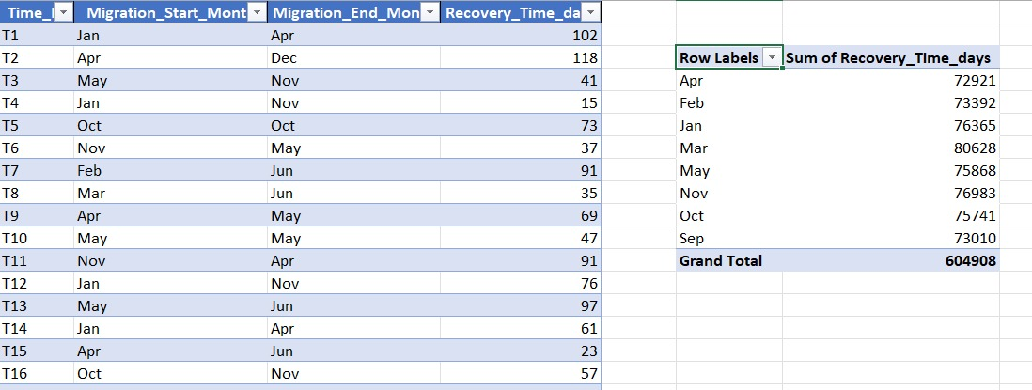
Fig no 2.11 Migration Dimension Table

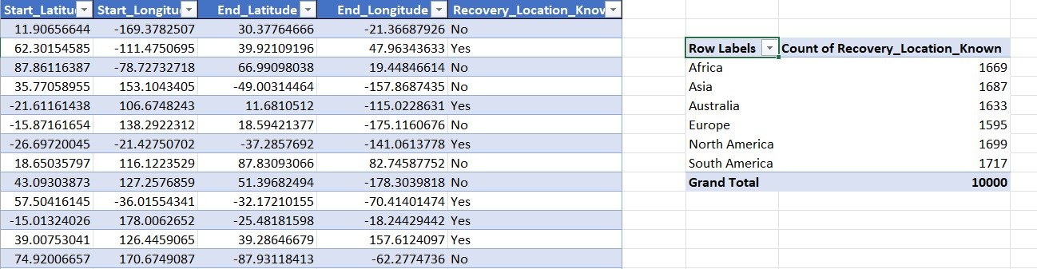
Fig no 2.12 Location Dimension Table
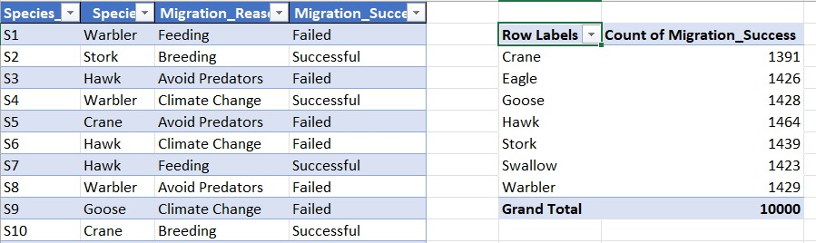
Fig no 2.13 Species Dimension Table
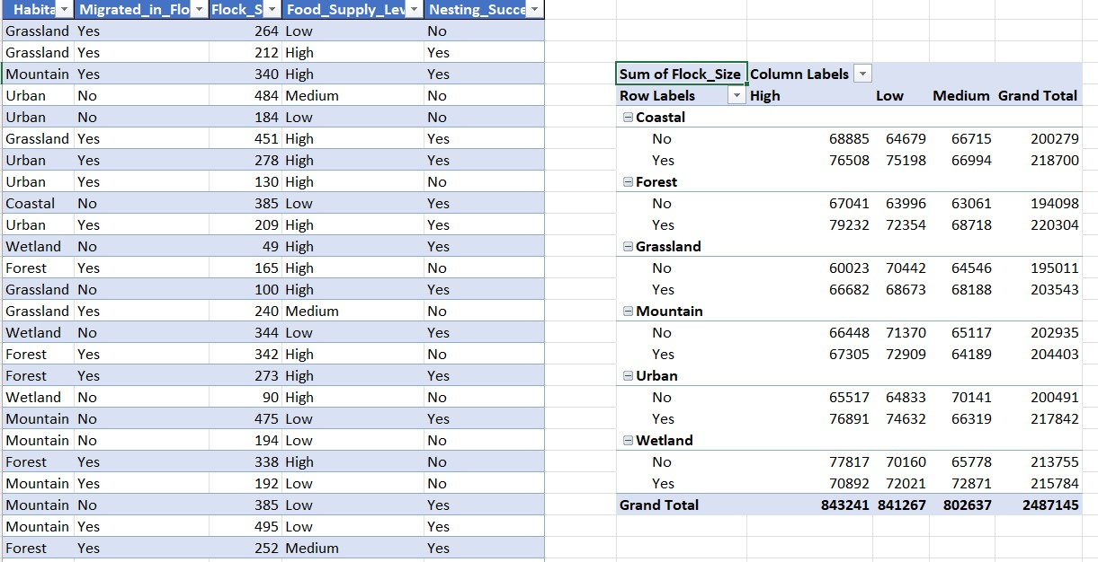
Fig no 2.14 Habitat Dimension Table
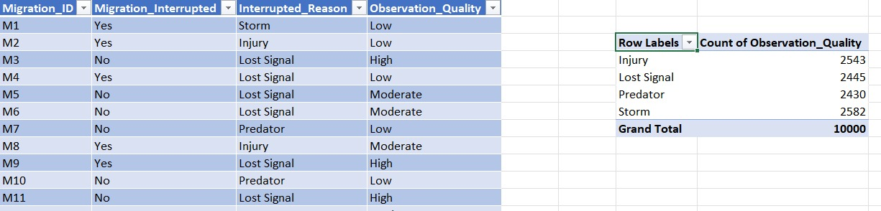
Fig no 2.15 Migration Dimension Table
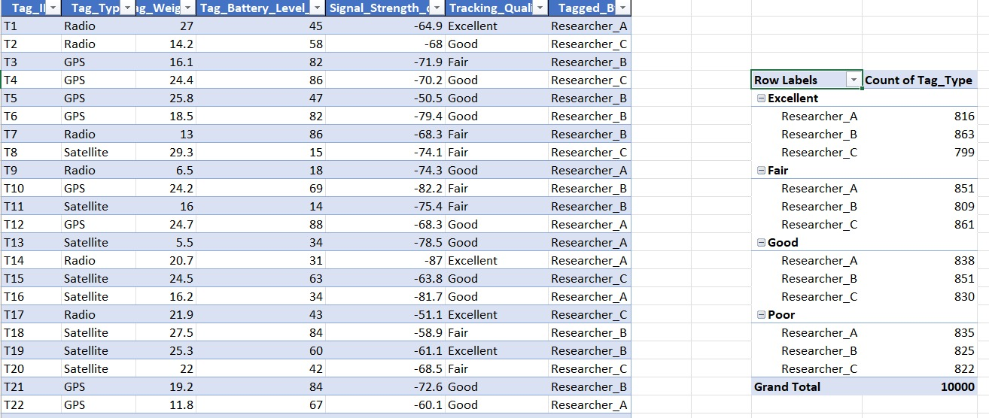
Fig no 2.16 Tag Dimension Table
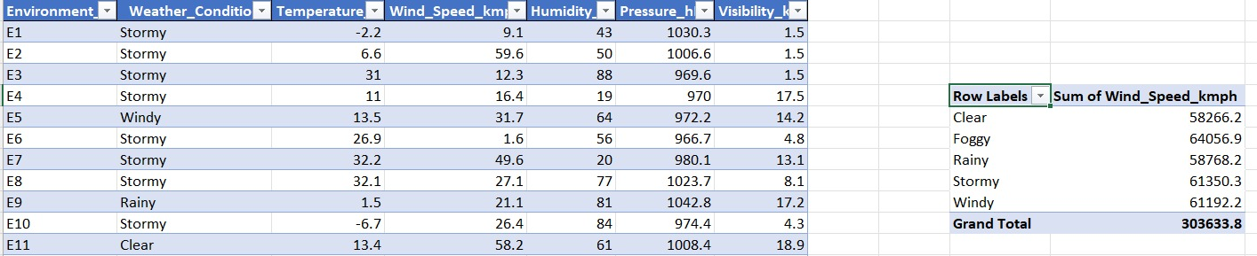
Fig no 2.17 Environment Dimension Table

Result:
Thus, the analytical operations of Online Analytical Processing such as Rollup, Drill down, Slicing, Dicing, Pivot in Cube Multi-Dimensional data model was performed using Microsoft Excel.

